Step by Step Manual to Using AskNLearn E-Portfolio for Reading Portfolio
- Log in to AskNLearn website at http://lms.asknlearn.com/CEDARGIRLSS
- Go to the homepage and search under “Secondary Higher Chinese”. Look for the file name assigned by your teacher under E-Portfolio.
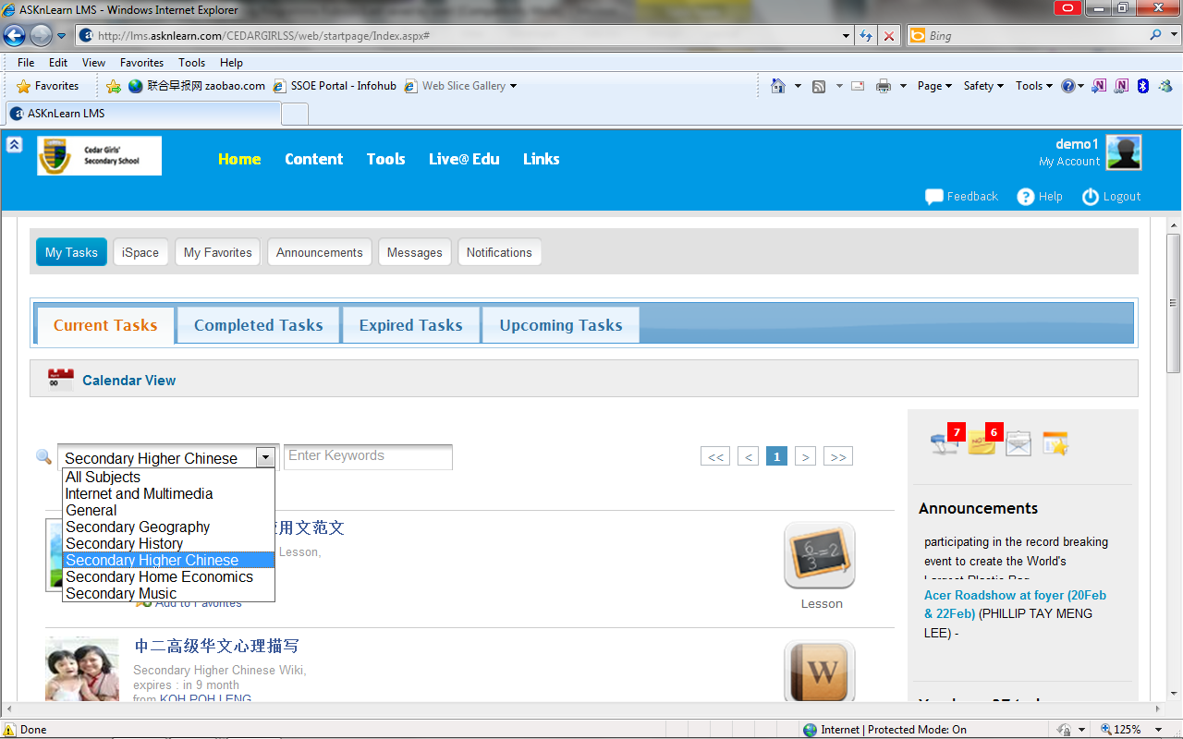
- Once you have found the file name, click the name of the file.

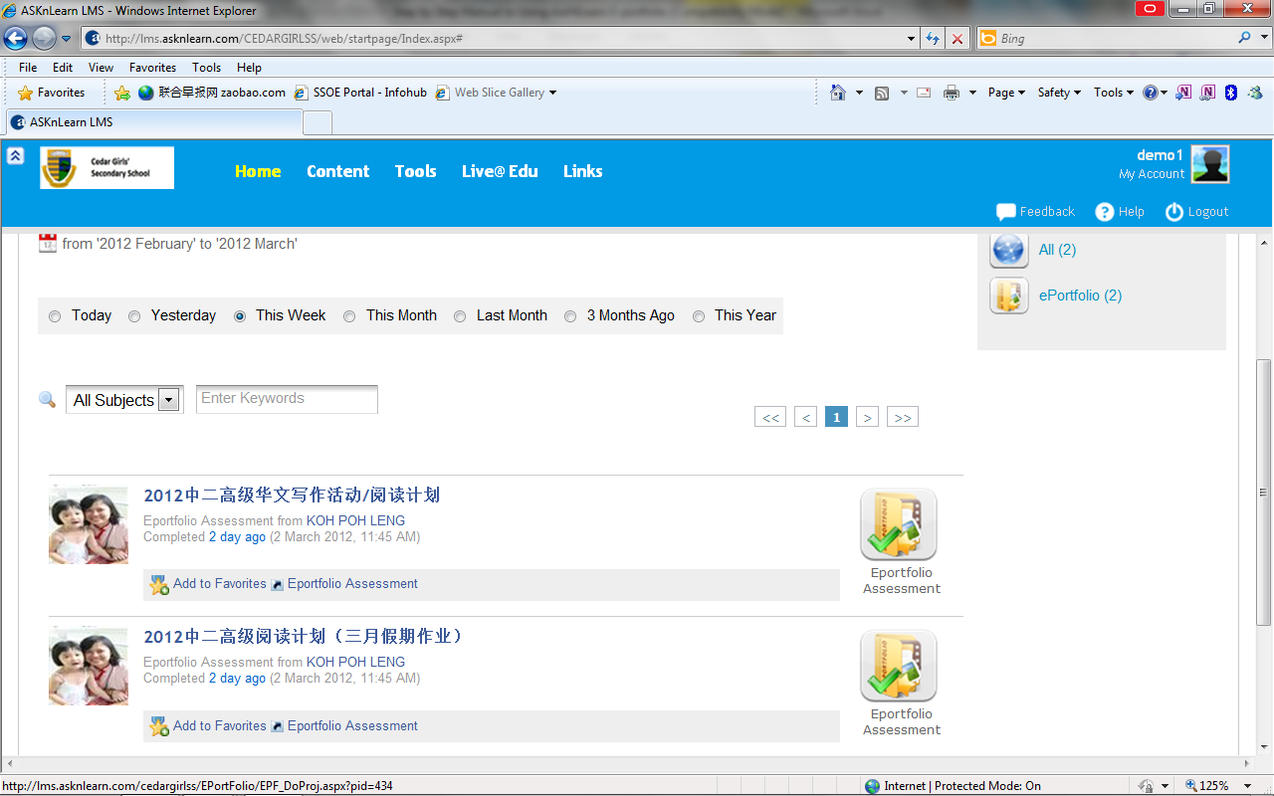
- You will see the instructions for the assignment and a “Do Assessment” button below. Click on the button to start doing the assignment.
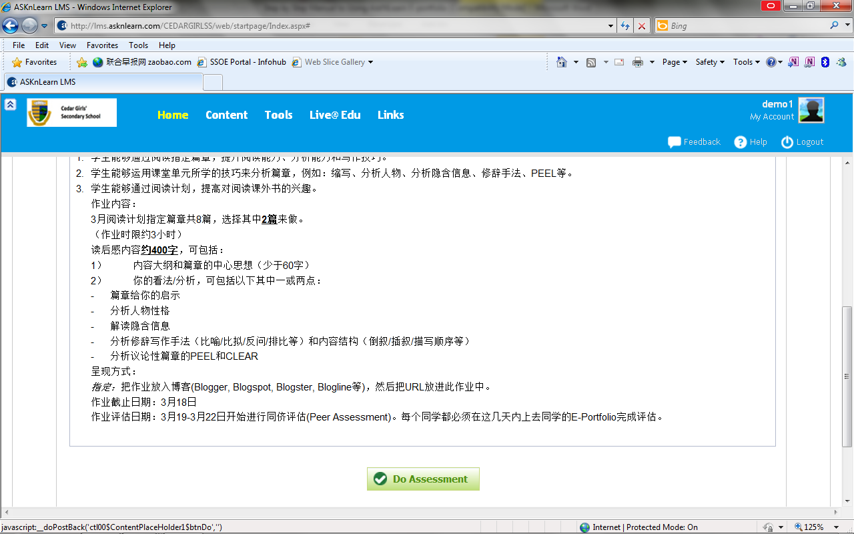
- Once you have entered the page, enter your URL of your blog into the space under “My Reflections”. Make sure you have copied your blog’s URL address correctly and the URL address will be underlined when you press “enter”. (You may want to open your blog, copy the URL address and paste it onto the reflection space for accuracy. Make sure you have given permission for us to view your blog or change your blog settings to “public”, see below). For those who are using the LMS’s personal blog, for easy reference, please paste the blog’s URL onto the reflection space as well.
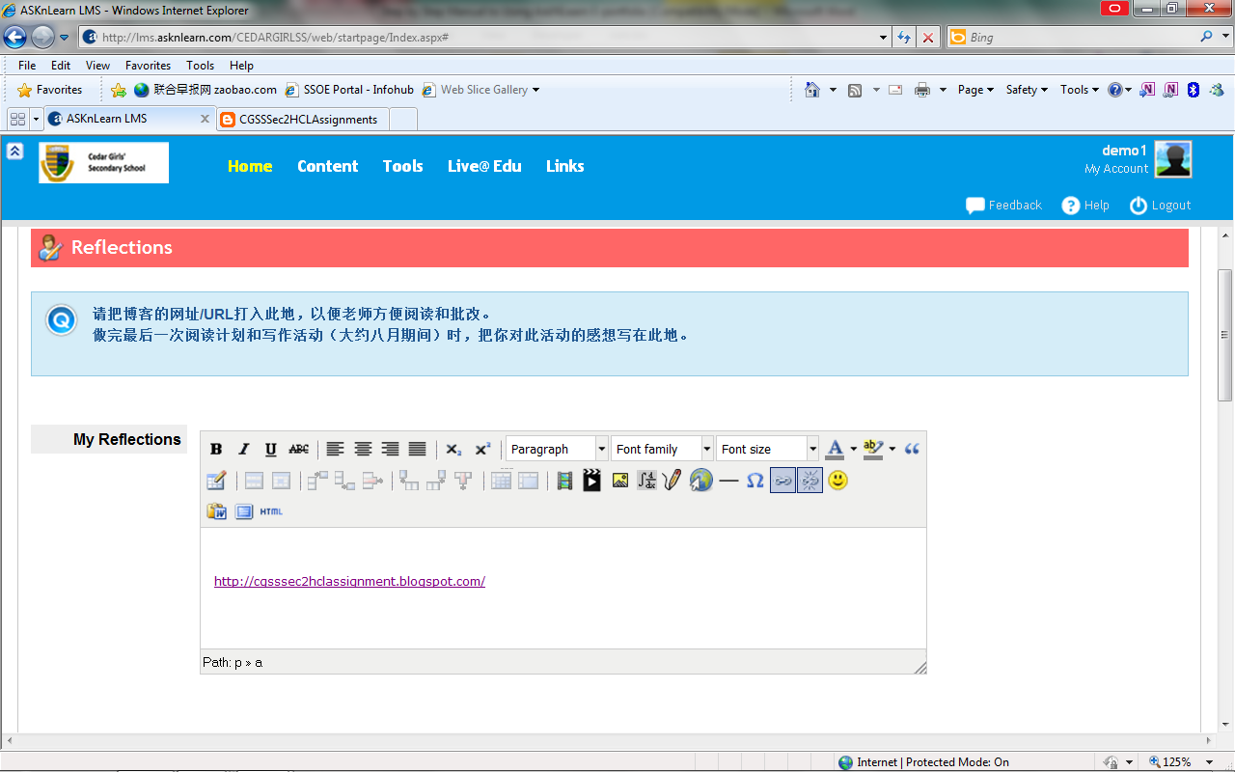
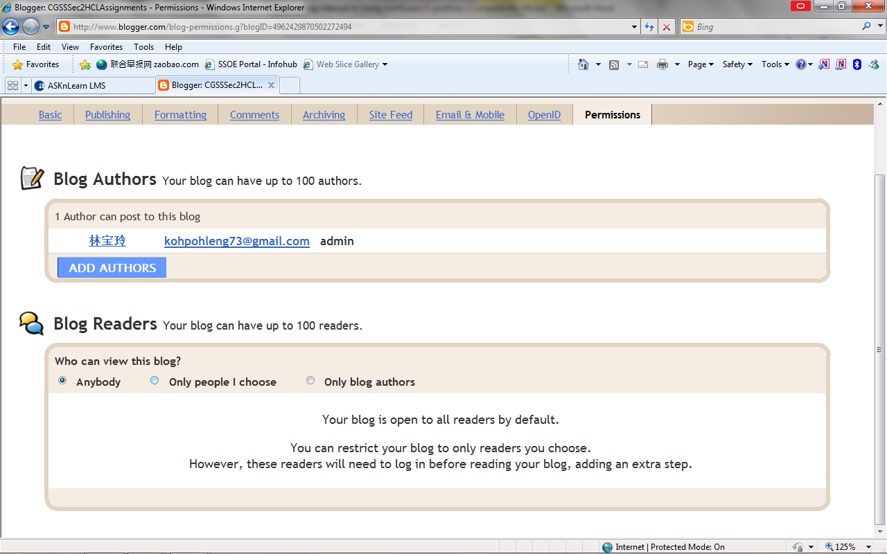
- Scroll to the bottom and press “Save Assessment”.
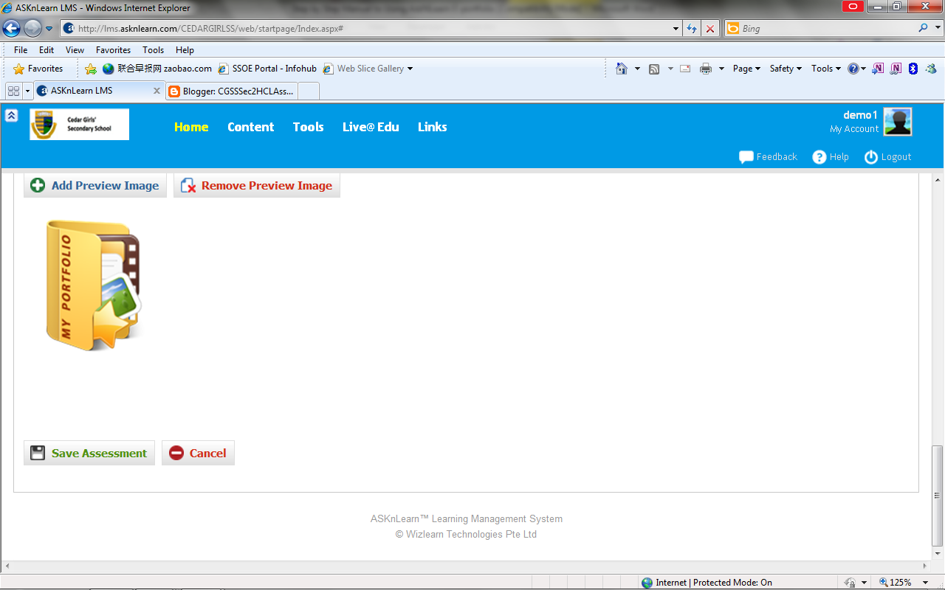

- You will see your blog URL on this page as well as the rubrics. To do the self-assessment component, press “ Use Rubrics”.
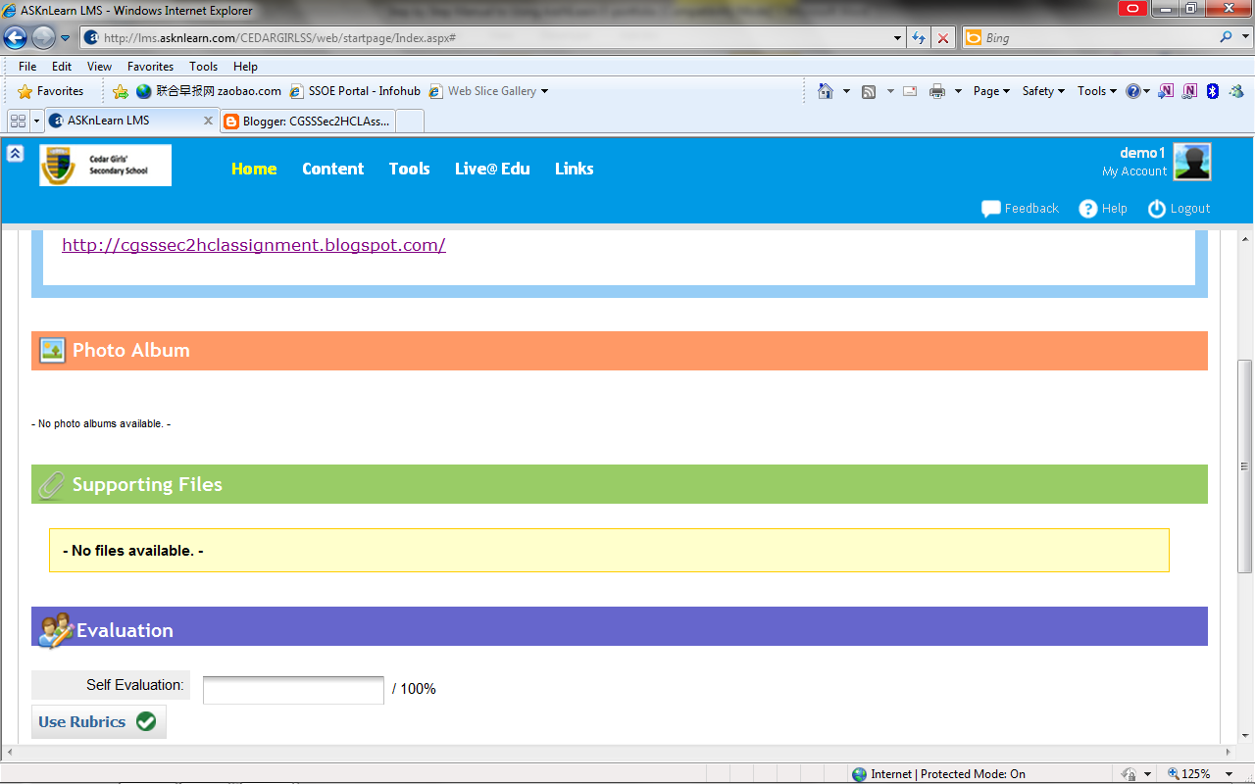
- Use the rubrics you saw in the page and click on the points best described your work. The total points will appear below. If you want to add in any comments, type in under “comments” in Chinese. When you have finished, press “save”.
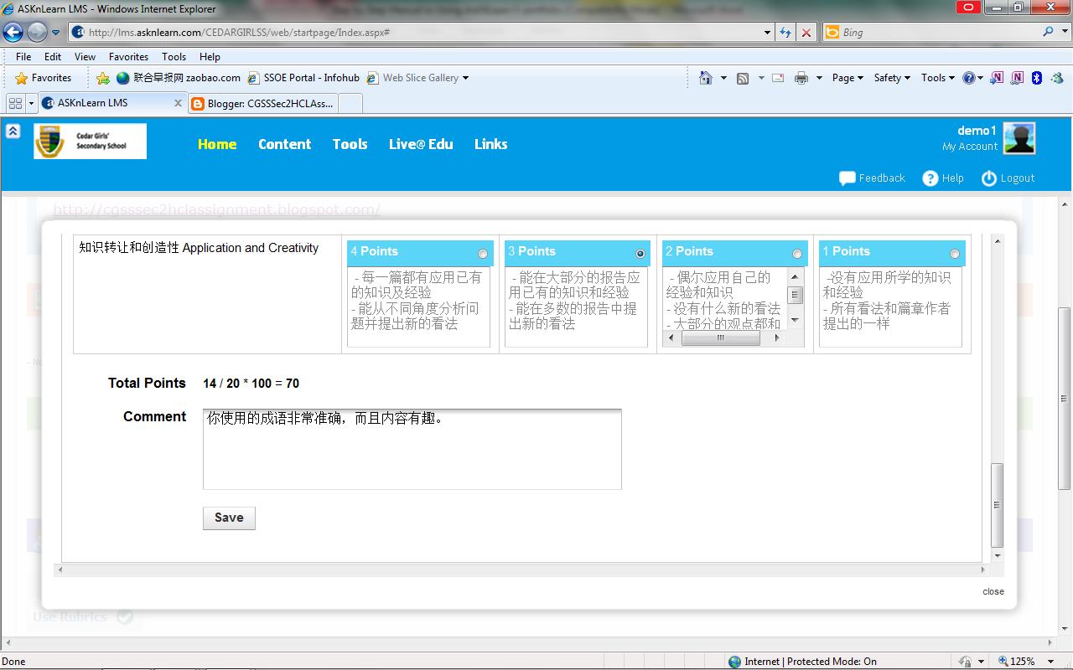

- You will see a webpage message saying “save successful”. Press “ok”.
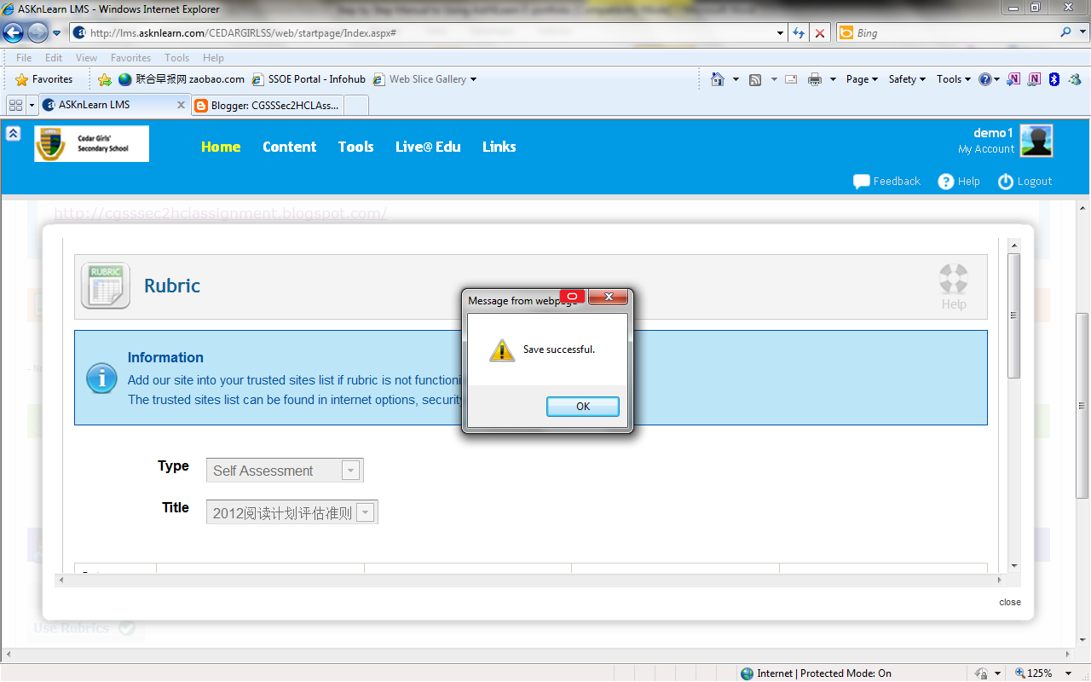
- You will return to the page you have seen previously with your marks reflected at the “Evaluation” section. If you need not make any changes, press “Submit Marks”.
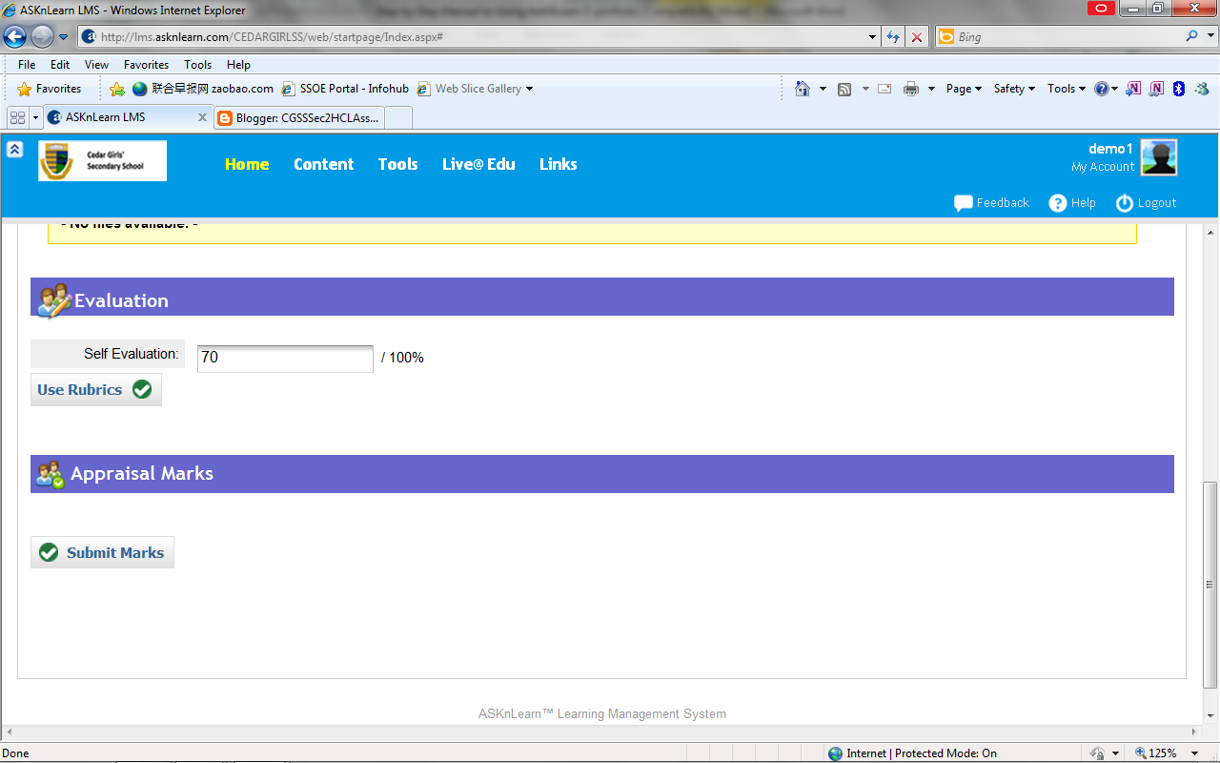

- You will come to a page saying that your assessment has been successfully submitted. You can change your self-assessment marks any time before the due date.
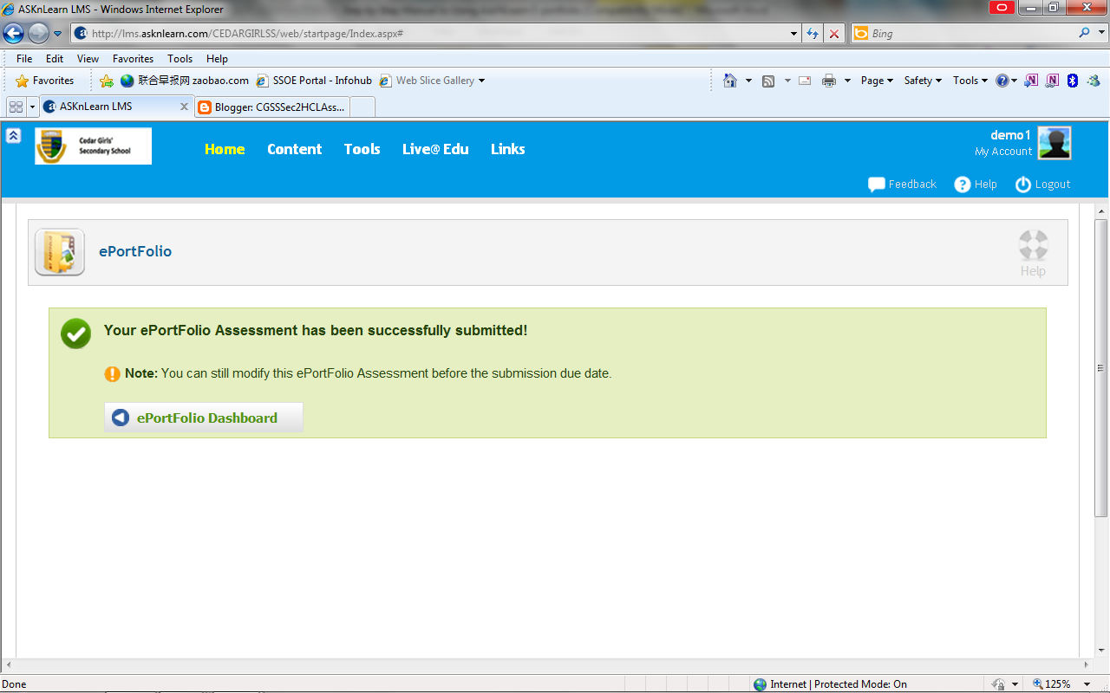
- Click on the” E-Portfolio Dashboard” when you have finished. When you are doing the assessment for your peers, find your peer’s E-portfolio first. Press “Appraisal” when you have found her name and complete steps 7-11 to mark her portfolio. 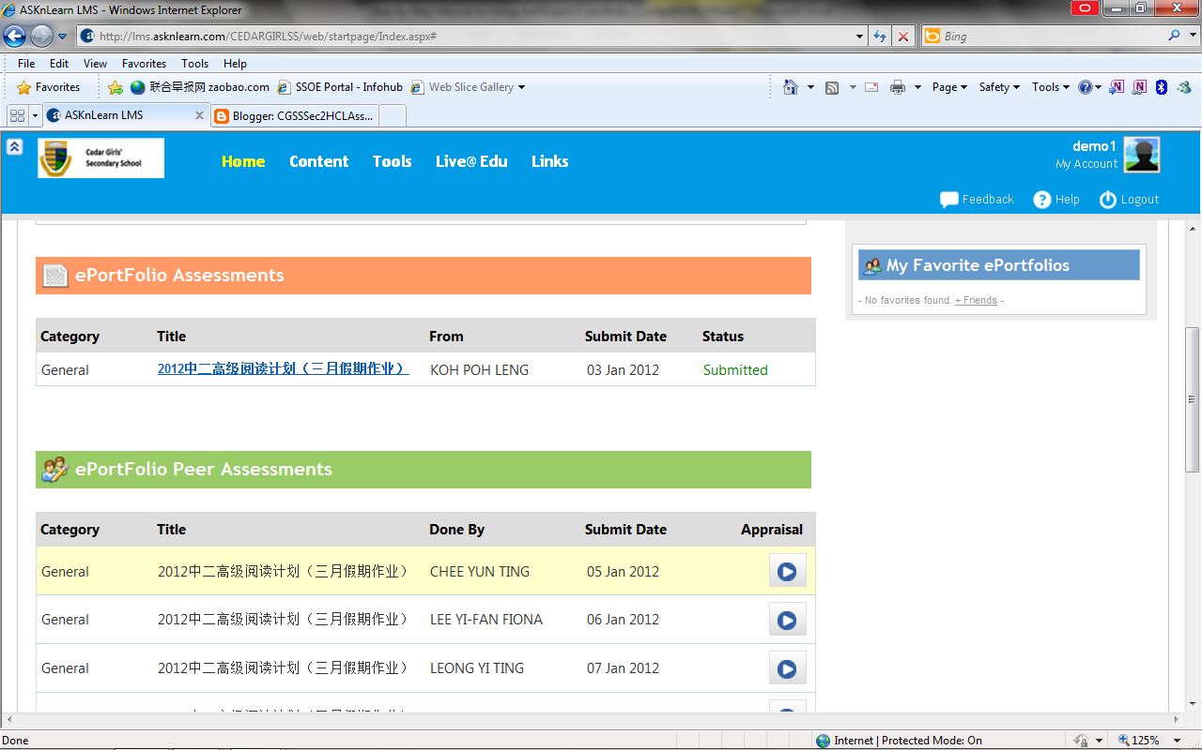
*Please consult your teacher promptly when you meet with any problem. Check with your teacher if they can view your blog before the submission deadline.

